This document describes the California Department of Health Care Access and Information’s (HCAI) web posting requirements regarding the HCAI Hospital and System Equity Reports and HQI’s recommendation.
In accordance with Health and Safety Code Section 127373, subdivision (a)(3), each hospital shall annually post its Equity Report on the hospital’s internet website.
- The Equity Report must be accessible via a link that includes the words “Equity Report” or a substantially similar term, such as “Equity” or “Health Equity.”
- This link must be:
  - Clearly visible on the main landing page of the hospital’s website when accessed using a standard internet browser,
  - Presented in an easily readable font size, and
  - Does not require scrolling to be seen.
This requirement is further defined in Sections 95303(d)(7) and 95304, as part of the steps in submitting Equity Reports. A hospital system may post a single consolidated equity report if the publication complies with the requirements outlined above. If revised reports are submitted pursuant to Section 95308, subdivisions (e) and (f), they must also be updated and posted accordingly.

Posting Recommendation for Hospitals/Systems
To comply with state regulations, hospitals are encouraged to ensure the following steps are taken when publishing Equity Reports:
- Homepage Visibility
  - The Equity Report link must be placed directly on the homepage (no subpages) in a location that does not require scrolling.
  - Example: A link titled “Equity” or “Equity Report” appears in the top navigation bar, as illustrated in the image below.
- Clear Labeling
  - The hyperlink text should clearly indicate the nature of the report, such as “Equity Report,” and must not be hidden under unrelated menu items.
- Annual Updates
  - Post the most recent version of the Equity Report no less than annually, and update it whenever revisions are submitted. After submission of your CSV, HCAI generates a PDF report for you. HQI recommend posting that PDF to your website to comply with the web posting requirements.
For reference, below is an example of compliant link placement. The word “Equity” is visible in the top-level navigation bar, without scrolling:
Link example: https://hqinstitute.org/equity_report/
Link placement example:
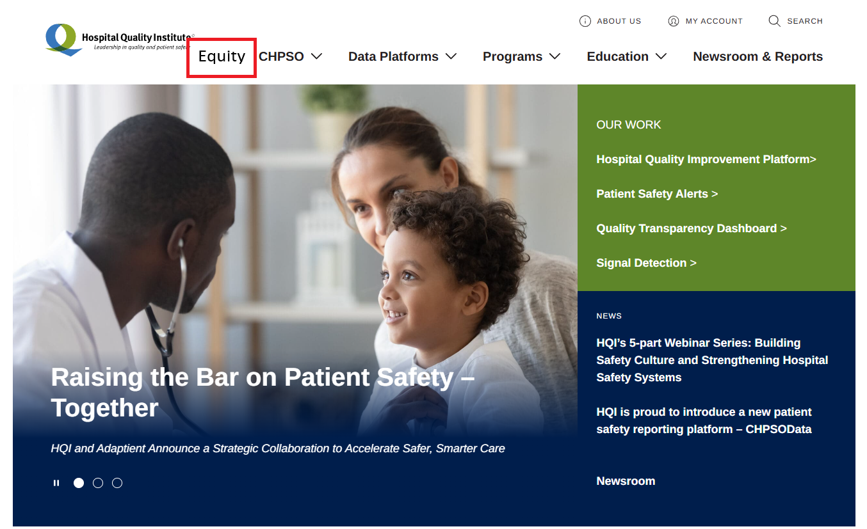

Disclaimer: This document contains recommendations from HQI. The definitive source of truth is HCAI, and hospitals are advised to contact HCAI directly for confirmation or clarification.

